***Section* 2.6 – Improper Integrals**

***Definition***

Integrals with infinite limits of integration are ***improper integrals***.

|  |  |
| --- | --- |
| 1. If  is continuous on , then |  |
| 1. If  is continuous on , then |  |
| 1. If  is continuous on , then |  |

In each case, if the limit is finite we say that the improper integral ***converges*** and that the limit is the ***value*** of the improper integral. If the limit fails to exist, the improper integral ***diverges***.

***Example***

Is the area under the curve  from *x* = 1 to *x* = ∞ finite? If so, what is its value?

***Solution***

|  |  |
| --- | --- |
|  |  |











 ***L’Hôpital Rule***





***Example***

Evaluate 

***Solution***









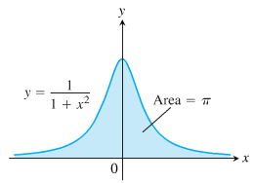 



















***Example***

For what value of *p* does the integral  converge? When the integral does converge, what is its value?

***Solution***

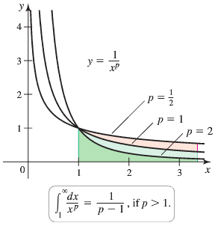If   







If  









**Integrands with Vertical Asymptotes**

***Definition***

Integrals of functions that become infinite at a point within the interval of integration are ***improper integrals***.

If the limit is finite we say that the improper integral ***converges*** and that the limit is the ***value*** of the improper integral. If the limit does not exist, the integral ***diverges***.

|  |  |
| --- | --- |
| 1. If  is continuous on , then |  |
| 1. If  is continuous on , then |  |
| 1. If  is continuous on , then |  |

***Example***

Investigate the convergence of 

***Solution***









The limit is infinite, so the integral diverges.

***Example***

Evaluate 

***Solution***

The integrand has a vertical asymptote at *x* = 1 and is continuous on [0, 1) and (1, 3].











***Example***

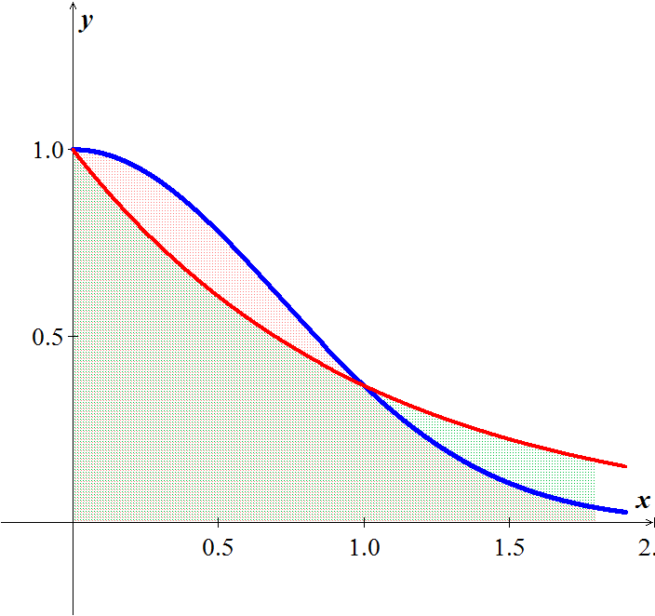Does the integral  converge?

***Solution***





The integral converges

***Theorem* − Direct Comparison Test**

Let  and  be continuous on [*a*, ∞) with  for all . Then

1. 
2. 

***Theorem* − Limit Comparison Test**

If the positive functions  and  are continuous on [*a*, ∞), and if



Then



Both converge or both diverge

***Example***

Show that  converges by comparison with . Find and compare the two integral values.

***Solution***

The functions  and  are positive and continuous on [1, ∞). Also,







Therefore,  converges because  converges.

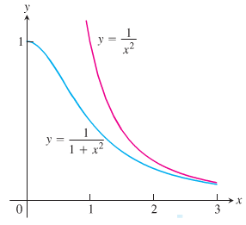







***Example***

Let *R* be the region bounded by the graph of  and the , for .

1. What is the volume of the solid generated when *R* is revolved about the ?
2. What is the surface area of the solid generated when *R* is revolved about the ?
3. 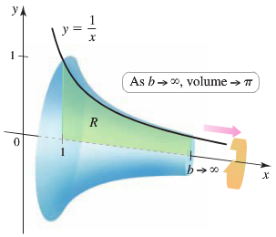What is the volume of the solid generated when *R* is revolved about the ?

***Solution***

1.  







1.  











1.  





***Exercises*** ***Section* 2.6 – Improper Integrals**

(**1 − 81**) Evaluate the integrals

|  |  |  |  |  |  |  |  |
| --- | --- | --- | --- | --- | --- | --- | --- |
|  | |  | | |  | | |
|  | |  | | |  | | |
|  | | |  | | |

(**82 − 85**) Find the area of the unbounded shaded region

|  |  |
| --- | --- |
|  |  |
|  |  |

1. Find the area of the region *R* between the graph of  and the on the interval  (if it exists)
2. Find the volume of the region bounded by  and the  on the interval  is revolved about the .
3. Find the volume of the region bounded by  and the  on the interval  is revolved about the .
4. Find the volume of the region bounded by  and the  on the interval  is revolved about the .
5. Find the volume of the region bounded by  and the  on the interval  is revolved about the .
6. Find the volume of the region bounded by  and the  on the interval  is revolved about the .
7. Find the volume of the region bounded by  and the  on the interval  is revolved about the .
8. Find the volume of the region bounded by  and the  on the interval  is revolved about the .
9. Find the volume of the region bounded by  and the  on the interval  is revolved about the .
10. Find the volume of the solid generated by revolving the region bounded by the graphs of , , and  about the .

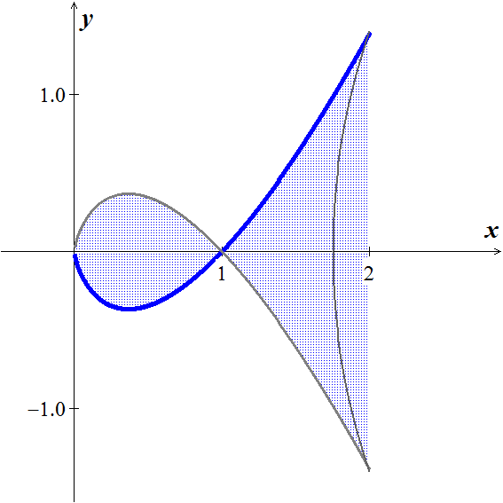

1. The region between the *x*-axis and the curve



is revolved about the *x*-axis to generate the solid.

Find the volume of the solid.

(**97 − 98**) Consider the region satisfying the inequalities

1. Find the area of the region
2. Find the volume of the solid generated by revolving the region about the .
3. Find the volume of the solid generated by revolving the region about the .

|  |  |
| --- | --- |
|  |  |

1. Find the perimeter of the hypocycloid of four cusps 
2. Find the arc length of the graph  over the interval 
3. The region bounded by  is revolved about the to form a torus. Find the surface area of the torus.
4. Find the surface area formed by revolving the graph  on the interval  about the 
5. The magnetic potential *P* at a point on the axis of a circular coil is given by



Where *N, I, r, k*, and *c* are constants. Find *P*.

1. A “semi-infinite” uniform rod occupies the nonnegative . The rod has a linear density *δ*, which means that a segment of length  has a mass of . A particle of mass *M* is located at the point . The gravitational force *F* that the rod exerts on the mass is given by



Where *G* is the gravitational constant. Find *F*.

1. Let *R* be the region bounded by the graph of  and the 
2. Let *S* be the solid generated when *R* is revolved about the . For what values of *p* is the volume of *S* finite for ?
3. Let *S* be the solid generated when *R* is revolved about the . For what values of *p* is the volume of *S* finite for ?
4. Let *S* be the solid generated when *R* is revolved about the . For what values of *p* is the volume of *S* finite for ?
5. Let *S* be the solid generated when *R* is revolved about the . For what values of *p* is the volume of *S* finite for ?
6. The solid formed by revolving (about the ) the unbounded region lying between the graph of  and the   is called ***Gabriel’s Horn***.

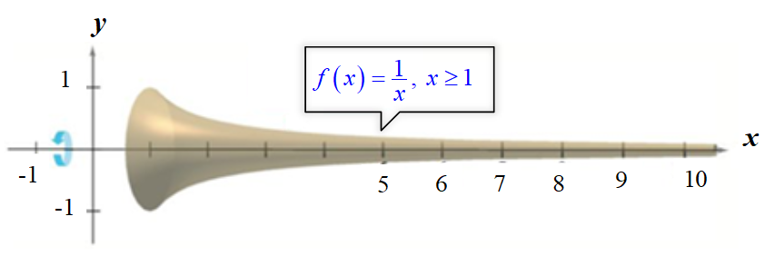

Show that this solid has a finite volume and an infinite surface area.

1. Water is drained from a 3000-*gal* tank at a rate that starts at 100 *gal/hr*. and decreases continuously by 5% /*hr*. If the drain left open indefinitely, how much water drains from the tank? Can a full tank be emptied at this rate?
2. Let , where *a* is a real number.
3. Evaluate  and show that its value is independent of *a*.

(***Hint***: split the integral into two integrals over  and ; then use a change of variables to convert the second integral into an integral over .)

1. Let *f* be any positive continuous function on 

Evaluate 

(***Hint***: Use the identity )

1. Let *R* be the region bounded by , the , and the line , where .
2. Find the volume  of the solid generated when *R* is revolved about the  (as a function of *a*).
3. Find the volume  of the solid generated when *R* is revolved about the  (as a function of *a*).
4. Graph  and . For what values of  is ?
5. Let *R* be the region bounded by the graph of  and the , for . Let  and  be the volumes of the solids generated when *R* is revolved about the and the , respectively, if they exist.
6. For what values of *p* (if any) is ?
7. Repeat part (*a*) on the interval .
8. Let  be the region bounded by the graph of  and the  on the interval  where  and . Let be the region bounded by the graph of  and the  on the interval . Let  and  be the volumes of the solids generated when  and  are revolved about the . Find and graph the relationship between *a* and *b* for which .
9. Suppose that a boat is positioned at the origin with a water skier tethered to the boat at the point (30, 0) on a rope 30 *feett.* long. As the boat travels along the positive y-axis, the skier is pulled behind the boat along an unknown path , as shown

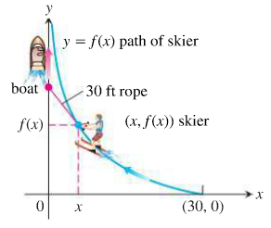

1. Show that 

(*Hint*: Assume that the skier is always pointed directly at the boat and the rope is on line is on a line tangent to the path .)

1. Solve the equation in part (a) for , using 
2. Many chemical reactions are the result of the interaction of 2 molecules that undergo a change to produce a new product. The rate of the reaction typically depends on the concentrations of the two kinds of molecules. If *a* is the amount of substance *A* and *b* is the substance *B* at time *t* = 0, and if *x* is the amount of product at time *t*, then the rate of formation of *x* may be given by the differential equation



Where *k* is a constant for the reaction. Integrate both sides of this equation to obtain a relation between *x* and *t*.

1. If 
2. If 

Assume in each case that  when 